Name: Date: ll words

The sound (l) is represented by the letters ll when it comes after a short vowel.

Remember: Say the word aloud, then say each letter aloud as you write it e.g. 'bell, b ... e ... l ... l'

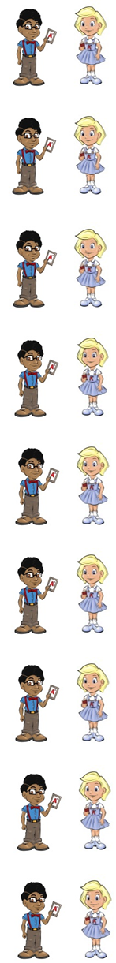

When the bell rings you need to line up.
¶¥e[l[l ¶¥e[l[l
Gail fell over Neil's foot.
½e[l[l ½e[l[l
If you are not ill, you are well.
¶ºÖ[l[l ¶ºÖ[l[l
A pill is a another name for a tablet.
¶p[i[l[l ¶p[i[l[l
A till is where your money goes in the shop.
¶t[i[l[l ¶t[i[l[l
Gail has a doll that she plays with.
ªd]Šl[l ªd]Šl[l
The words roll, poll and stroll are naughty red words that belong to Neil and Nina because the letter o makes its long sound.
A poll asks people what they think about something.
¶p]Šl[l ¶p]Šl[l
If you roll a ball, you push it along the floor.
¶›Šl[l ¶›Šl[l
A stroll is a slow walk.
¡[t[›Šl[l ¡[t[›Šl[l

Now test yourself without looking at the words and check for yourself if you got them all right. Practice writing any words that you made mistakes on again.

© www.SaveTeachersSundays.com 2013
Name: Date: ll words

The sound (l) is represented by the letters ll when it comes after a short vowel.

Remember: Say the word aloud, then say each letter aloud as you write it e.g. 'bell, b ... e ... l ... l'

Try to spell each word without looking at it.

When the rings you need to line up.

Gail over Neil's foot.

If you are not ill, you are .

A is a another name for a tablet.

A is where your money goes in the shop.

Gail has a that she plays with.

A asks people what they think about something.

If you a ball, you push it along the floor.

A is a slow walk.

Now check for yourself if you got them all right. Practice writing any words that you made mistakes on again.

© www.SaveTeachersSundays.com 2013

